**ADK Experiment no – 01 (A) ROLL NO=04**

**Aim:** Write the program for the following.

(A). Create a program that asks the user to enter their name and their age. Print out a message addressed to them that tells them the year that they will turn 100 years old.

**Practical Implementation**:-

**Code**:-

import datetime

name =input("Hello! enter the name =")

age =int(input("enter the age ="))

year_now = datetime.datetime.now()

print("You will turn 100 in " + str(int(100-age) + int(year_now.year)))

**Output:**

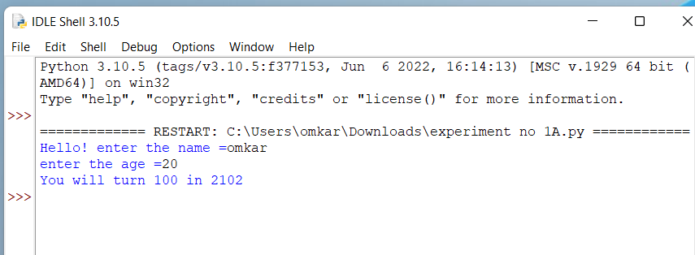

**Conclusion:**This is program successfully run.